Academic Integrity Policy

Ralph J. Bunche Middle School

Atlanta, Georgia

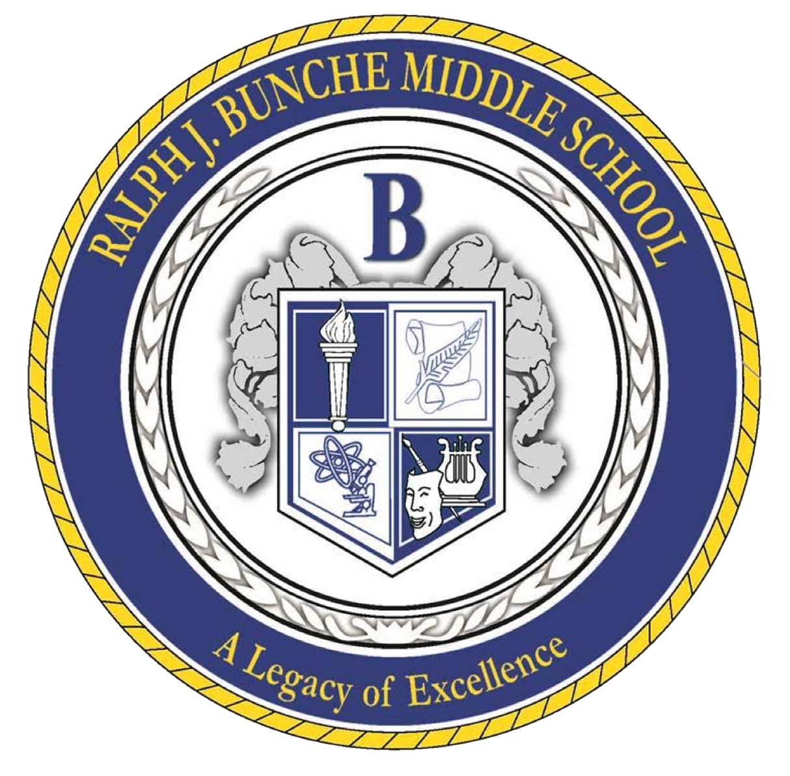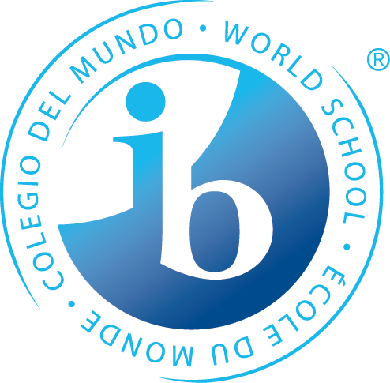

**The Bunche Mission Statement**

Through rigorous learning experiences and a challenging international education program, Ralph J. Bunche will develop 21st-century lifelong learners who are competent, caring, and contributing members of a global society and prepared for high school and beyond.

**Purpose**

At Ralph J. Bunche Middle School (BMS), we firmly believe that academic honesty is the responsibility of all individuals involved in the educational process, including students, teachers, staff, administrators, and families. To ensure that we maintain high standards of academic integrity, a committee comprising teachers, leadership staff, and administrators from BMS’ International Baccalaureate Middle Years Programme (IB MYP) developed this document to clearly outline and define the critical components of our Academic Honesty Policy.

**Philosophy**

In the Middle Years Programme (MYP), students face significant pressure from parents and peers to succeed. As a school, we are responsible for assisting in the student's personal development and ensuring that they understand and practice academic honesty to a high standard. Promoting personal integrity is also a crucial aspect of this policy.

IB learners are expected to act with integrity and honesty, with a strong sense of fairness, justice, and respect for the dignity and rights of people everywhere. Therefore, students are encouraged to take responsibility for their actions and the consequences that follow. At BMS, we expect our students to embody the traits of the IB Learner Profile, which are integrated into the curriculum and school culture. These profile traits serve as guidelines for our Academic Honesty Policy and include:

**Key Focus:**

-Principled – those who act with integrity and honesty and take responsibility for their actions

∙Inquirers – those who acquire the skills necessary to conduct inquiry and research;

∙Knowledgeable – those who explore concepts, ideas, and issues;

∙Open-minded – those who are accustomed to seeking and evaluating a range of points of view and

∙Risk-takers – those who are brave and articulate in defending their beliefs.

When students and teachers practice these qualities, they promote behaviors and skills that lead to success in the classroom and future educational endeavors. These qualities also prepare students to be influential global citizens.

**Defining Concepts of Academic Honesty**

IB defines academic misconduct as “behavior that results in, or may result in, the student or any other student gaining an unfair advantage in one or more assessment components.” This includes:

A. CHEATING AND ACCOMPLICE TO CHEATING

Cheating is behavior that results in a student making a deliberate choice to gain an unfair advantage in an assessment situation. An accomplice to cheating is someone who makes the intentional choice to help another individual cheat. Cheating includes but is not limited to:

1. Copying another student’s work (with or without their knowledge);

2. Copying assessment tasks;

3. Forgery;

4. Using unauthorized notes or other study aids during an assessment;

5. Submitting work as their own that has been copied and

6. Communicating with other students during an assessment.

B. COLLUSION

At BMS, collusion is behavior that helps another student cheat. This help includes but is not limited to:

1. Giving intellectual property (their own or others) to a student with intent to cheat;

2. Provide information on how to obtain another student’s intellectual property;

3. Provide information on how to obtain assessment tasks (before examination);

4. Forging documents for another student;

5. Helping copy documents for another student;

6. Providing unauthorized notes to another student during an assessment and

7. Taking an online assessment or assignment under another student’s identity.

C. COLLABORATION

Collaboration is a necessary 21st-century skill. Therefore, BMS desires all our students to learn to collaborate ethically on academic projects. However, students must understand the difference between honest and dishonest collaboration. Collaboration is cooperative work with other students on academic tasks. Students are assigned individual responsibilities in collaborative work to create interdependence and group accountability. Students are only allowed to collaborate if the teacher has assigned a collaborative task or has approved student requests for collaboration. Any behavior during collaboration that falls under the definition of cheating or accomplice to cheating will be reported and addressed according to the terms of this policy. In addition, if a student allows fellow students (during collaborative work) to perform most/all of the required tasks, this will be considered cheating.

D. AUTHENTIC AUTHORSHIP

Authentic authorship is a student’s work based on their “individual and original ideas with the ideas and work of others fully acknowledged” (Academic Honesty). It is important to note that students may use resources that support their ideas, but they must also correctly cite the source using MLA format.

E. Duplication

Duplication occurs when a student submits the same work for different assessment tasks or across different subject areas. For instance, a student cannot utilize their summative project from a Language and Literature unit on environmentalism for a summative assessment in Science, unless the teachers have coordinated an interdisciplinary unit that includes a unified assessment task. Furthermore, a student is not permitted to submit a summative task completed in Language and Literature Year 1 for a task in Language and Literature Year 3, even if the nature of the task is similar. In essence, students are required to produce original work that meets the criteria for authentic authorship for each assessment task throughout their academic journey.

F. INTELLECTUAL PROPERTY

Intellectual property is defined as the ideas or work of another person, including professionals and students.

G. PARAPHRASING

Paraphrasing is the practice of rewording another individual's ideas using different vocabulary and sentence structure. The resulting paraphrased content typically exhibits a style distinct from that of the original author. While paraphrasing is an appropriate method for utilizing a source, it is essential to properly credit the original author through citations in MLA format, as it still relies on someone else’s ideas.

H. MALPRACTICE

Malpractice is defined as any act of academic dishonesty. This includes plagiarism, cheating, collusion, and duplication.

I. PLAGIARISM

Plagiarism is “using words, ideas, or products which belong to another person or source, without giving credit to the source from which it was taken” (qtd. in Carroll 3). Plagiarism can occur when a person tries to represent another person’s work as his/her own to obtain some benefit, credit, or gain. However, plagiarism can also occur unintentionally if a person does not acknowledge the work of others that helped him/her to complete the assessment task. Regardless of the motivation, plagiarism is unacceptable and can be avoided with proper teaching and learning.

J. Use of AI Tools

At Bunche Middle School, we guide our learners by showing them ways to use the tools for research and making them aware of how to identify misuse by properly citing sources.

K. CITATION AND FORMATTING

BMS will use the MLA citation format in all MYP classes and subject groups. Listed below are examples and websites to assist with MLA’s citation and formatting:

All BMS students have access to both libraries during school hours and before school begins at 8:30 a.m.

1. **Citation Machine**

http://citationmachines.net/

2. **Easy Bib**

http://www.easybib.com/

3. **Purdue English**

https://owl.english.purdue.edu/owl/section/2/

4. **Bibme**

<http://www.bibme.rog/>

**MLA In-Text Citations Examples**

∙Wordsworth stated that Romantic poetry was marked by a "spontaneous overflow of powerful feelings" (263).

∙Romantic poetry is characterized by the "spontaneous overflow of powerful feelings" (Wordsworth 263).

**MLA Works Cited Page Examples**

∙ "Blueprint Lays Out Clear Path for Climate Action." *Environmental Defense Fund*. Environmental Defense Fund, 8 May 2007. Web. 24 May 2009.

∙Clinton, Bill. Interview by Andrew C. Revkin. “Clinton on Climate Change.” *New York Times*. New York Times, May 2007. Web. 25 May 2009.

∙Ebert, Roger. "An Inconvenient Truth." Rev. of *an Inconvenient Truth*, dir. Davis Guggenheim. *rogerebert.com*. Sun-Times News Group, 2 June 2006. Web. 24 May 2009.

**Students who promote academic honesty…**

| **To Avoid Plagiarism** | |
| --- | --- |
| **Do** | **Do Not** |
| Submit authentic work that is based on their original ideas and acknowledge the ideas and the work of others. | Submit work without stating where it originated according to MLA or another appropriate format. |
| Cite sources using MLA and APA formats. | Copy work |
| Paraphrase ideas of another person or use in-text citations when appropriate. | Utilize other’s work |
| Use resources to promote your ideas. | Steal the ideas from resources and pass  them off as your own. |
| **When Collaborating** | |
| **Do** | **Do Not** |
| Collaborate to meet a joint assessment  goal. | Let one person do all the work. |
| Share ideas during collaborative tasks. | Allow someone to copy their work even  though the other person may change a few things. |
| Support classmates by asking questions and brainstorming ideas. | Give the answers. |
| **When Taking Tests** | |
| **Do** | **Do Not** |
| Look at their paper. | Look at the documents of others. |
| Keep the content of the test to themselves after taking it. | Tell other students the questions and/or  answers on the test. |
| Use notes and electronics approved by the teacher. | Use “cheat sheets” or devices that the teacher has not approved. |
| Report instances of violations of the academic honesty policy to teachers or administrators. | Keep cases of violations of the academic honesty policy secret from teachers or administrators. |

**Parents who promote academic honesty…**

| **To Avoid Plagiarism** | |
| --- | --- |
| **Do** | **Do Not** |
| Allow students the opportunity to complete complex tasks independently | Do the work for their students |
| Help their students balance their school workload so they are ready for tasks/tests on the day they are due to help students resist temptations to be academically dishonest. | Excuse their students from school so they  have more time to study or do a project. |

**Teachers who promote academic honesty…**

| **To Avoid Plagiarism** | **To Avoid Plagiarism** |
| --- | --- |
| **Do** | **Do Not** |
| Design inquiry-based assessment tasks that cannot be easily plagiarized. For example, “Suppose you were organizing tourism to Mars. What would you need to find out, and how would you market, etc…” | Design assessment tasks with simple answers that can easily be found online. For instance, a request to “Write about Mars”. |
| Assign work that elicits an original response, thereby discouraging plagiarism. | Assign work where the answers can be  directly “Googled”. |
| Teach how to properly cite all sources, including photographs, websites, music, and literature, and discuss when to cite depending on the types of assignments. | Give students research assignments without explaining how they would like the students to give credit to the source. |
| Teach students to reflect on what they have read and take appropriate notes by paraphrasing and writing down general statements from the text. | Allow students to copy/paste, highlight, or copy down entire paragraphs. |
| Focus on helping students understand how to help peers with assignments without providing all the answers or allowing others to copy their work, depending on the subject area. | Focus on punishing students for helping others on assignments before teaching them. |
| Model academic honesty in their resources and presentations. | Present the work of others as their own. |
| Monitor students during exams and tasks. | Provide undue assistance in the production of student work. |
| Keep exam papers and tests secure. | Leave exam papers out in the open. |
| Teach students Fair Use Guidelines | Let students think that academic honesty is just for the classroom. |
| State expectations for collaborative  and individual work. | Allow students to be unaware of the teacher's expectations for individual work. |

**Administrators who promote academic honesty…**

| **To Avoid Plagiarism** | **To Avoid Plagiarism** |
| --- | --- |
| **Do** | **Do Not** |
| Make expectations clear for both students and staff | I just hope students will be academically honest |
| Focus on teaching the skills for being academically honest rather than the consequences of dishonesty | Warn students not to plagiarize |
| Have an established and consistent progression of consequences when dishonesty occurs | Use the harshest consequences for the first offenders |
| Establish a school culture that actively encourages academic honesty | Tolerate academic dishonesty |
| Place the Academic Honesty Policy in the  handbook | Fail to make appropriate stakeholders aware of the Academic Honesty Policy |
| Inform staff and students through various media what constitutes malpractice and how it can be prevented | Assume everyone knows the policy |

**Academic Dishonesty Consequences**

Every student and employee is responsible for exhibiting honesty, trust, fairness, respect, and responsibility in academic work at all times to support a positive learning environment in the school. Cheating, plagiarism, and other acts of academic dishonesty are strictly prohibited.

Students who cheat on standardized testing or are repeatedly dishonest can face severe consequences, including expulsion or increased consequences. Examples of violations of this rule include, but are not limited to copying or "borrowing" from another source and submitting it as one's work; seeking or accepting unauthorized assistance on tests, projects, or other assignments; fabricating data or resources; providing or receiving test questions in advance without permission; or working collaboratively with other students when individual work is expected. Depending on the student's age, level of severity, or repetition, the administrator may utilize Level 1-3 interventions, supports, and disciplinary responses for this offense.

**Bibliography**

Atlanta Public Schools. Student Handbook. 2015.

Basic Academy. *Academic Honesty Policy*. 2015.

Bibme leaves the formatting to us.” *Bibme*. N.p., n.d. Web. 2007-2014.

Carroll, Jude. *Academic Honesty in the IB*. Cardiff: International Baccalaureate

Organization, 2012.

“Convert Your Works Cited into MLA, APA % Chicago Style Formats.” WorksCited4U:

Free APA, MAL & Chicago Works Cited Maker. N.P., n.d Web. 5 Sept. 2013

Franklin Academy. *Academic Honesty Policy*. 2014.

International Baccalaureate Organization. *Academic Honesty*. Cardiff: International

Baccalaureate Organization, 2011.

Purdue English online writing lab.” *Purdue English*. N.p., n.d. Web. 1995-2014.

“The Free Automatic Bibliography and Citation Generator.” *Easybib*. N.p., n.d. Web.

Sept. 2013.